**Assignment 1:**

SDLC Overview - Create a one-page infographic that outlines the SDLC phases (Requirements, Design, Implementation, Testing, Deployment), highlighting the importance of each phase and how they interconnect.

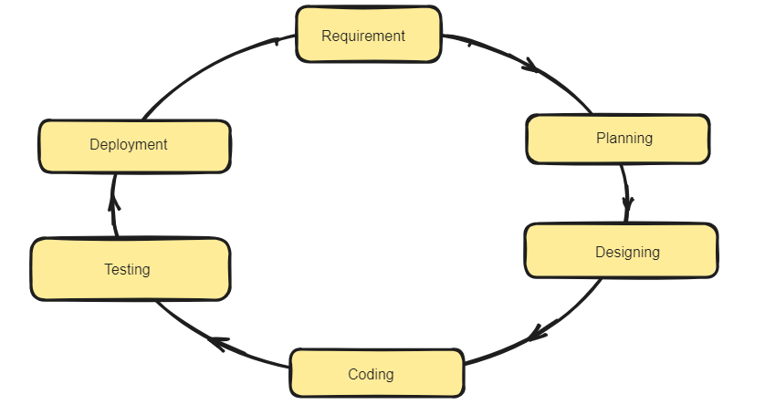

Software Development Life Cycle (SDLC) is a process used by the software industry to design, develop and test high quality softwares. Here the software which we have to make go through the each steps.

# Planning :-

* It is the very important part here we discuss the planning of the software.
* What should be the cost, phases ,time it takes.
* What is the objective of the project.
* What we need to create this project.

# Requirement:-

* What resources we need.
* Market data.
* Functionality which a app should have
* All the details will be provide.

# Design :-

* Once the requirement are understood, the design process take place.
* Its makes use of established patterns for application architecture (UI/UX) and software development. Decide which frameworks going to use.

# Coding:-

* Here we code the software according to the requirements.
* We use many types of programming languages.
* We also review the code.

# Testing :-

* Here when the the coding part is done we test the code.
* We provide multiple test cases to check it functionality.
* If we get the desired result the we go to the next phase.

# Deployment:-

* Here after testing phase done we got working app.
* And in this phase we deploy the project online.
* To the public domain to use the public

# Maintenance :-

* In it if we got any error according to the feedback we make changes.
* We make sure that our software keep working.
* Bugs and defect discovered in production must be reported and responded to which often work back into process.